Brief references and evidence of Promotion of Social Cohesion and Harmony
1. On 2nd June 2024 During social forestry day Druk Kirat Chhoetshog has Planted 50 sapling at Khasarapchu Meawang gewog,Thimphu.
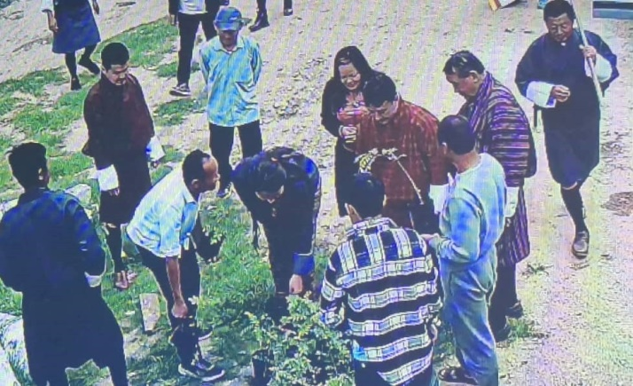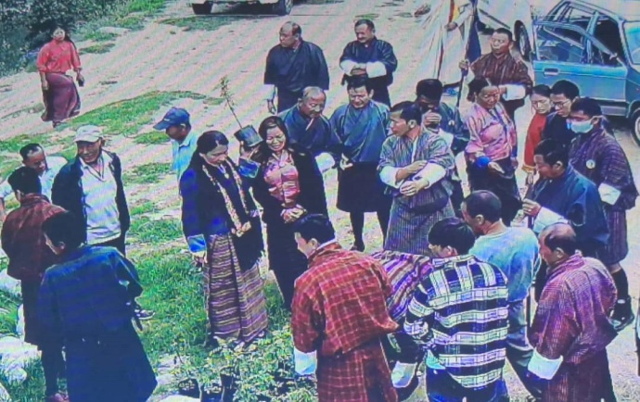
2. Transporting deceased individuals to cremation sites and other designated locations, particularly from Thimphu, Paro, Wangdi, and Punakha, presents significant challenges. In response to this issue, Druk Kirat Chhoetshok has been actively facilitating the transportation of deceased individuals to their respective areas since 2023, for the benefit of the community.
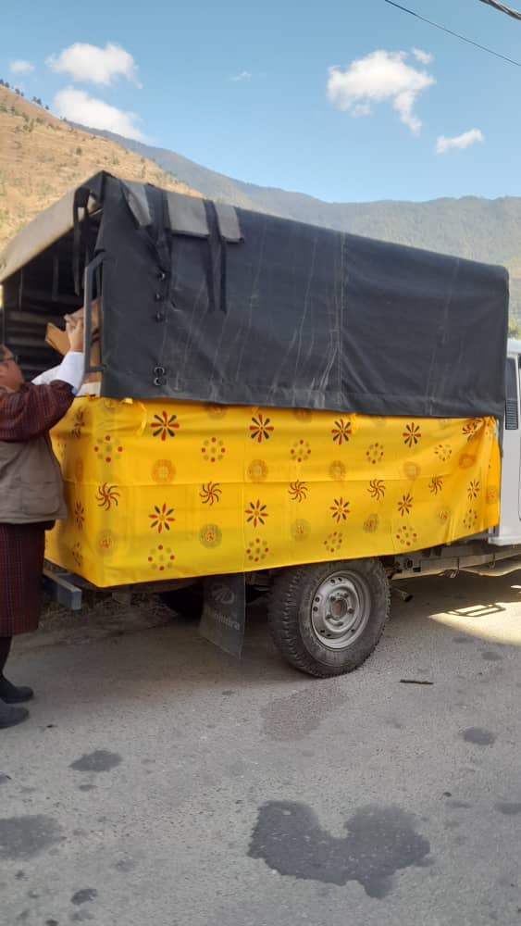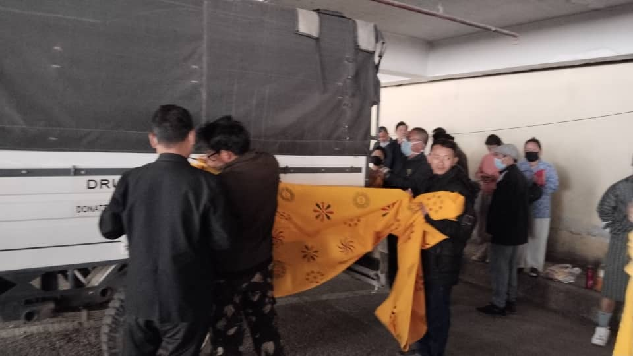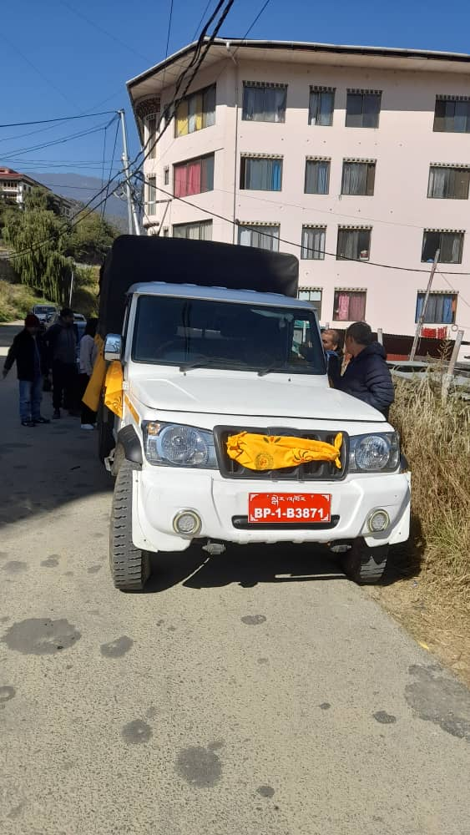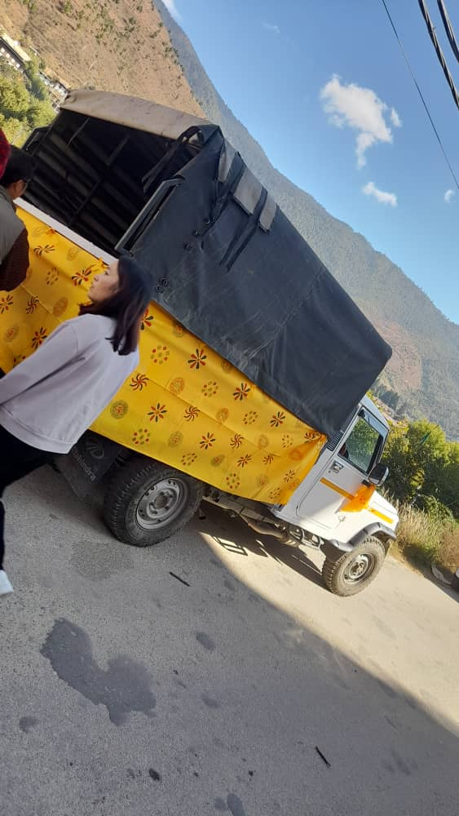3.On date 9 -13th November 2024 we extend our wishes for enduring peace in the nation, as well as for the happiness, prosperity, and longevity of the royal family, the promotion of world peace, human welfare, and the protection of all beings. Druk Kirat Chhoetshok, in collaboration with Zhung Dratshang and in the presence of HE Dorji Lopen Rinpochoe and HE Lyetshog Lopen Rinpochoe , has organized a five-day Meonlam, coinciding with Marngoe Chhokor (Udhaili Puja), scheduled from November 9 to 13, 2024, with offerings of divine fire smoke to the deities.
i. Cultural items and prayer
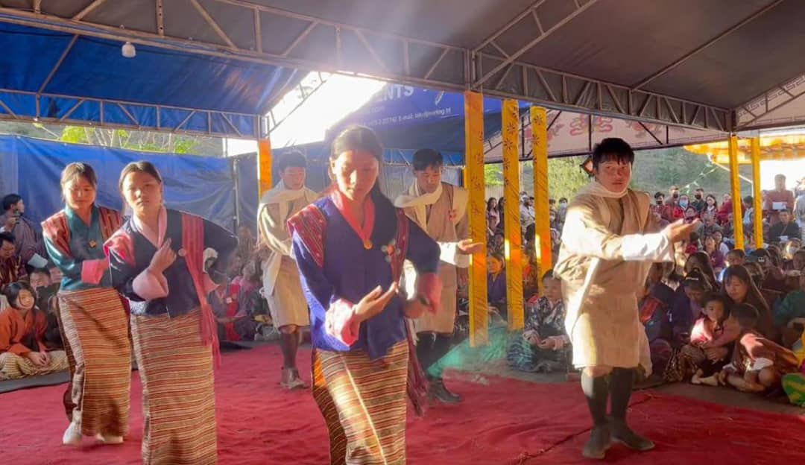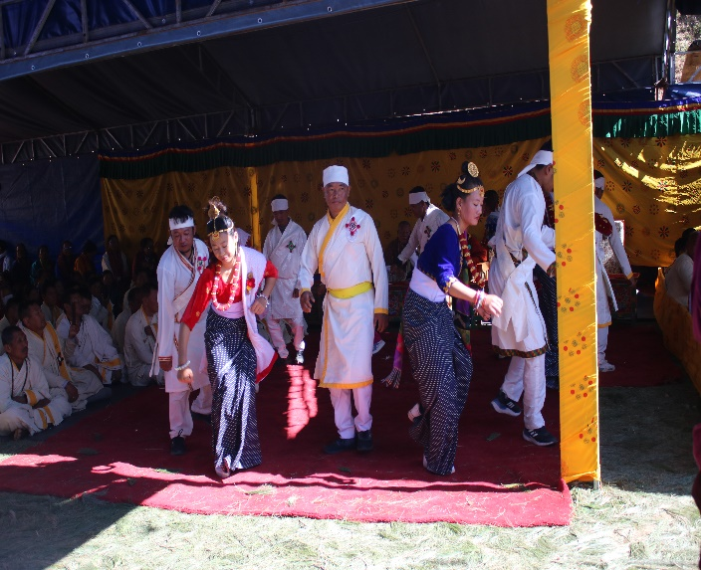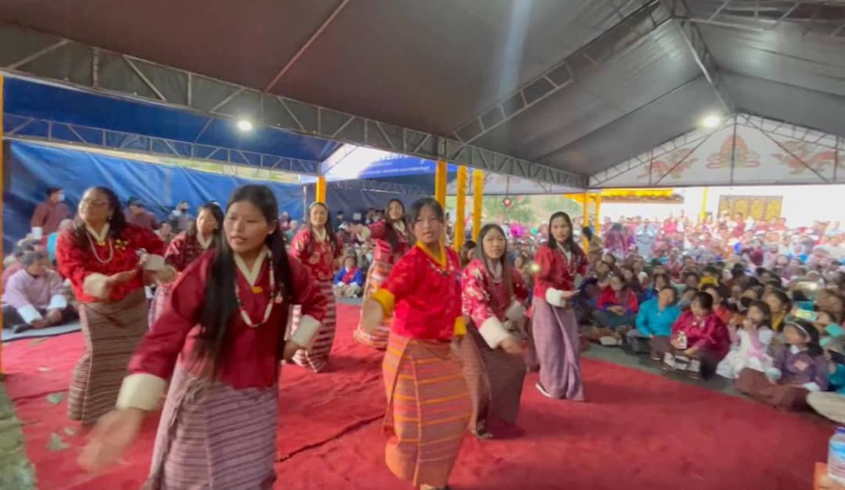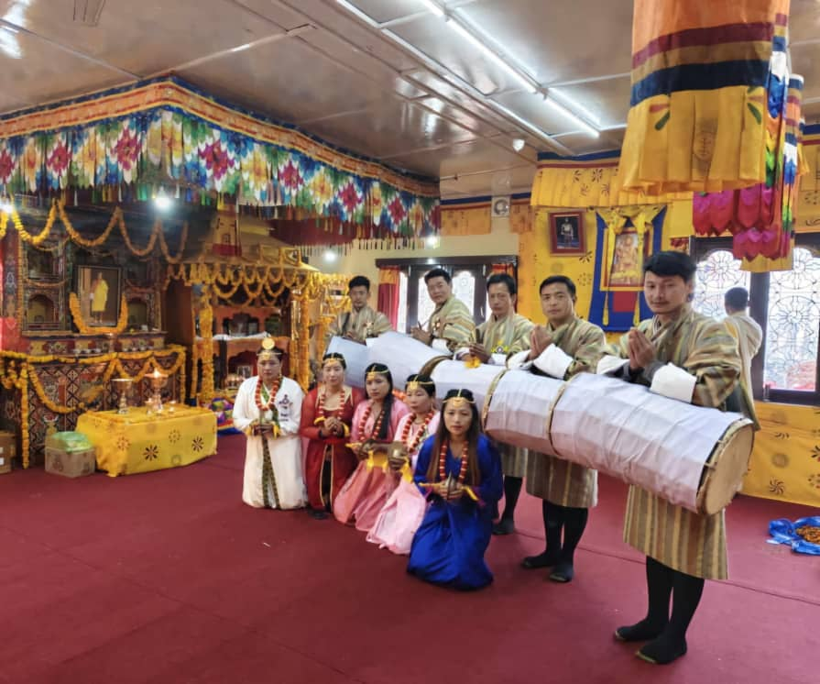

ii.Moenlam
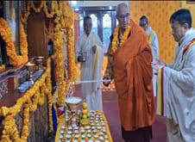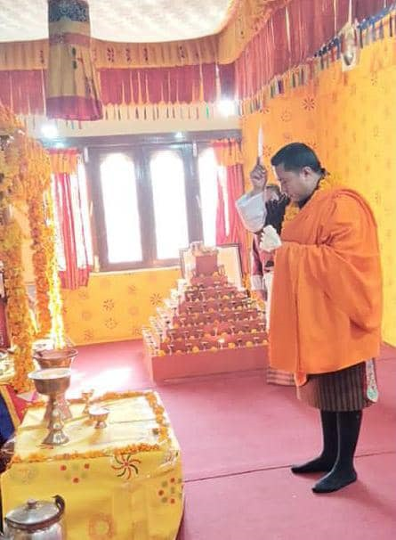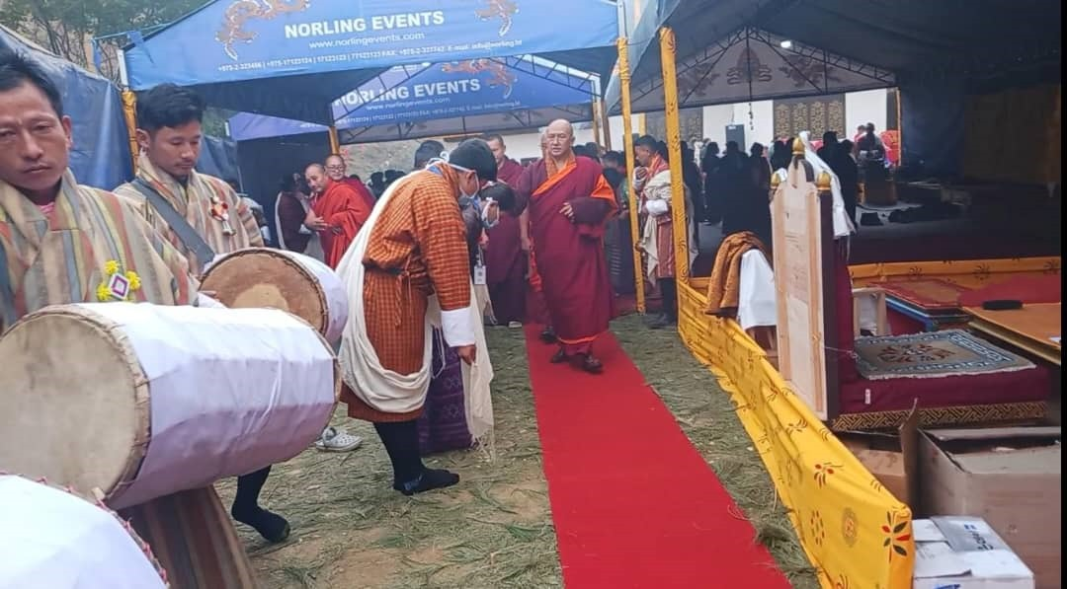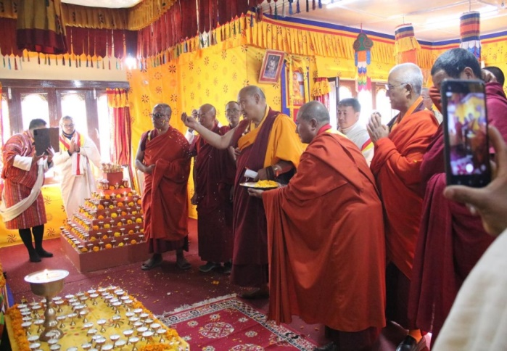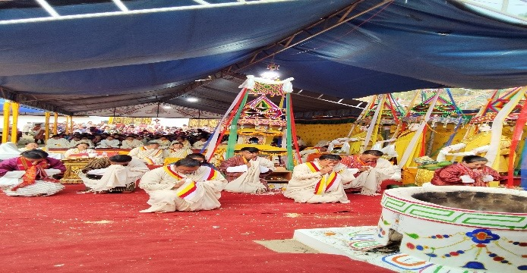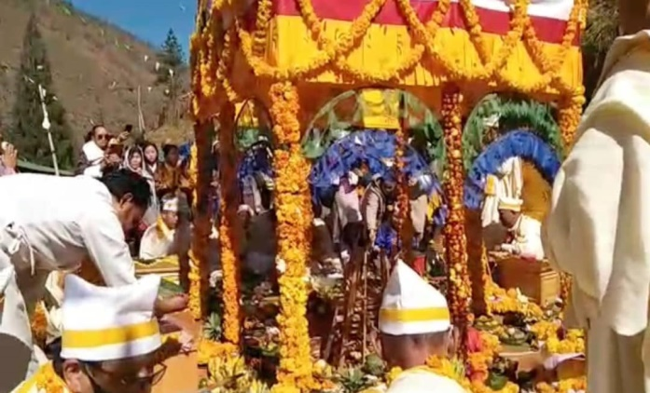

iii. The initiative aims to create an environmentally sustainable practice by replacing plastic plates with leaves during Moenlam, thereby reducing pollution.
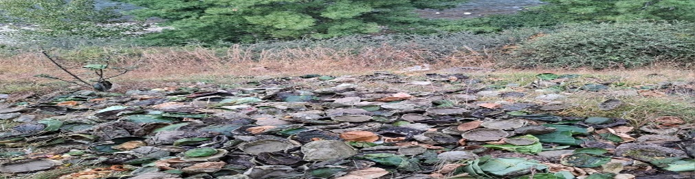

4. On 19th August 2024 in collaboration with the Druk Kirat Chhoetshog office secretariat, over 90 volunteers from various dzongkhags participated in the Shree Shiva, Vishnu, and Ganesh Maha Puran, organized by the Hindu Dharma Samudaya of Bhutan (HDSB) at the Devi Panchayan Mandir in Kuensel Phodrang, Thimphu, to provide physical support during the moenlam.
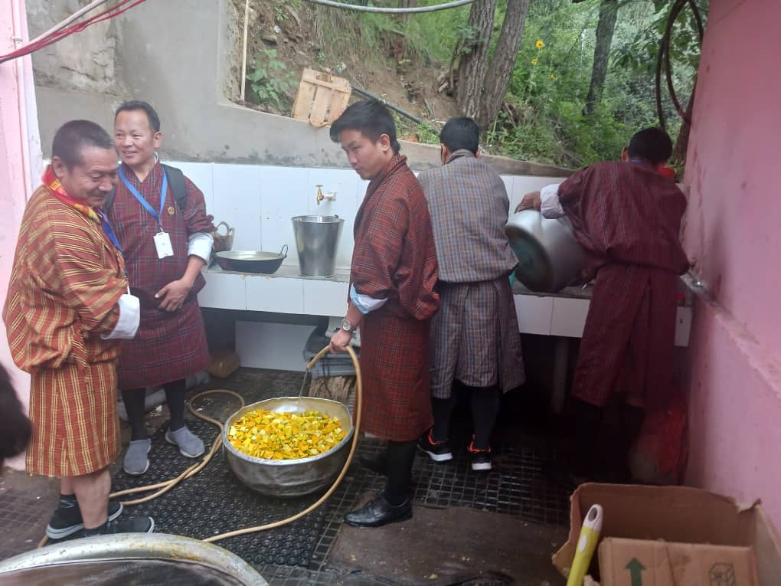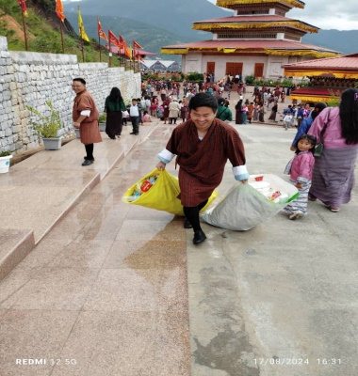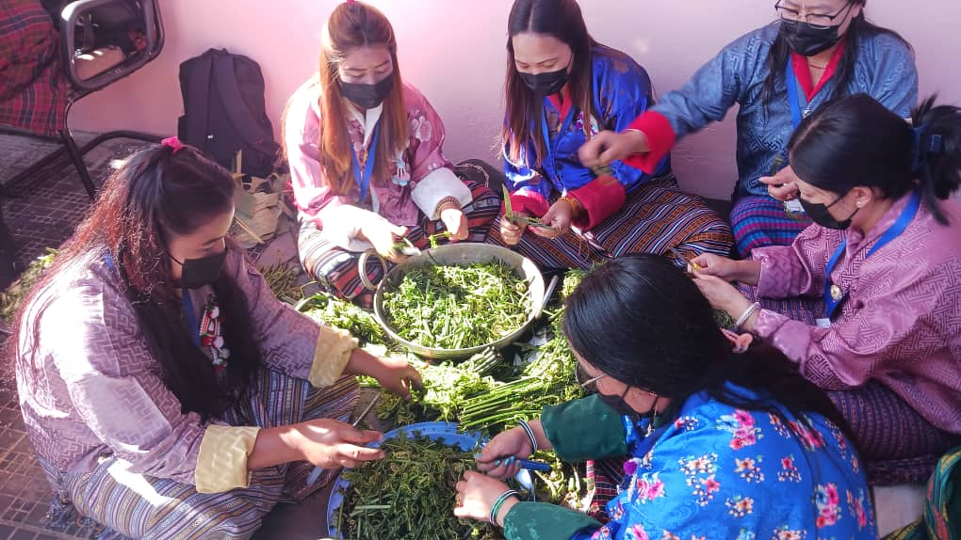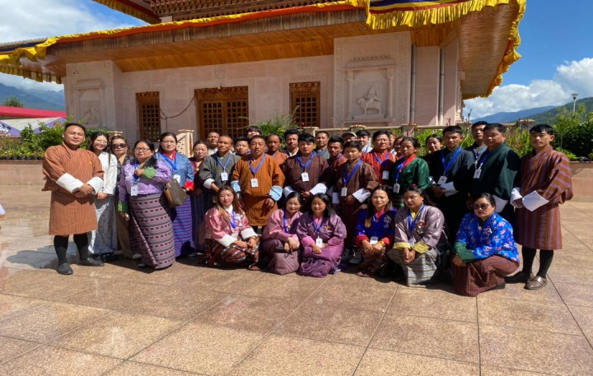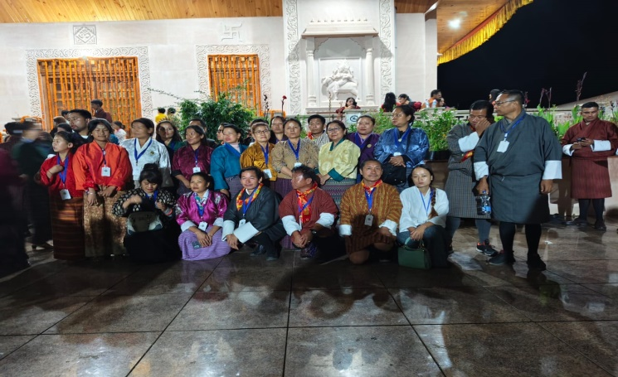

5. As articulated by His Majesty the Fourth Druk Gyelpo, "the future of our country lies in the hands of our youth." In recognition of this, during the School winter vacation, Druk Kirat Chhoetshog has organized a three-day Sewa Monlam to educate our youth about our nation, traditions, rituals, culture, religious consciousness, and societal values inherited from our ancestors. This event, which featured the Baja Guru, sports program, was held in the presence of Dagana Lam Neteen and Rinpoche Lhwang Dorji Tamang from Tsirang in Shamdolay, Kirat Chhoekhang, under Dagana Dzongkhag, from January 17 to 19, 2025.
i. Cultural and Sports
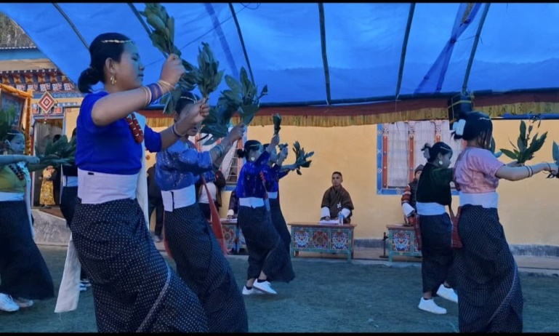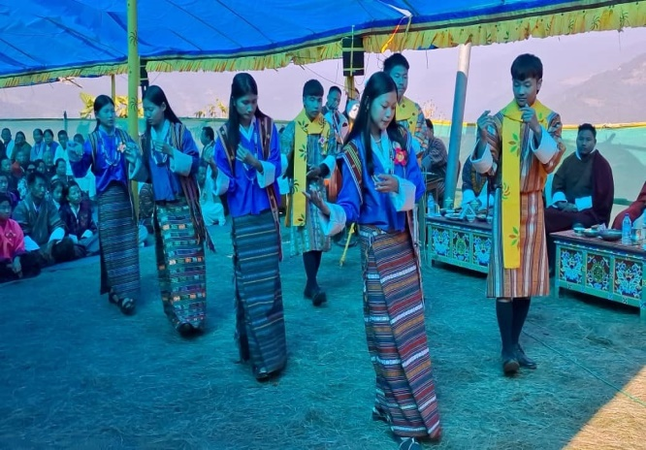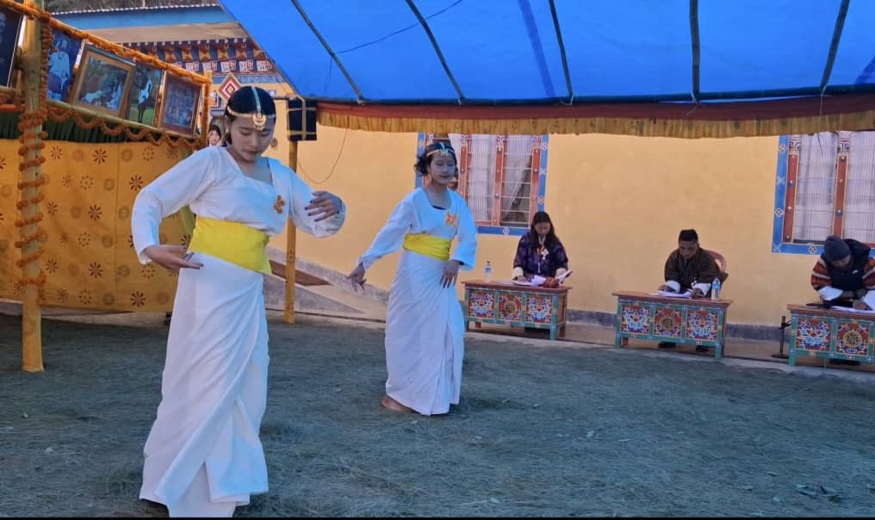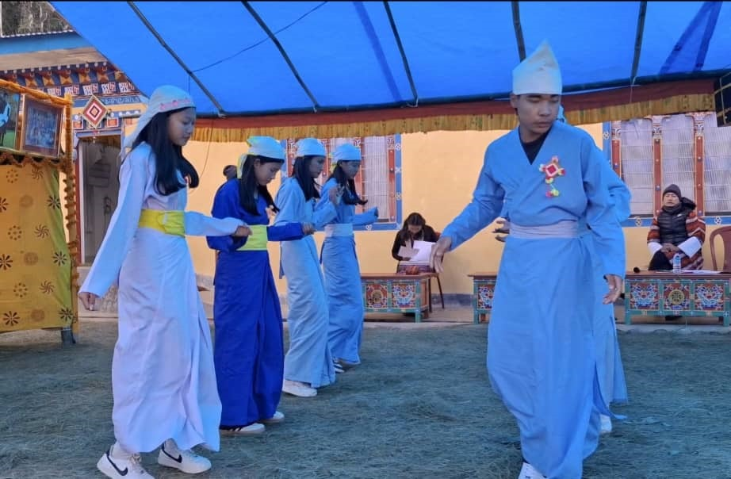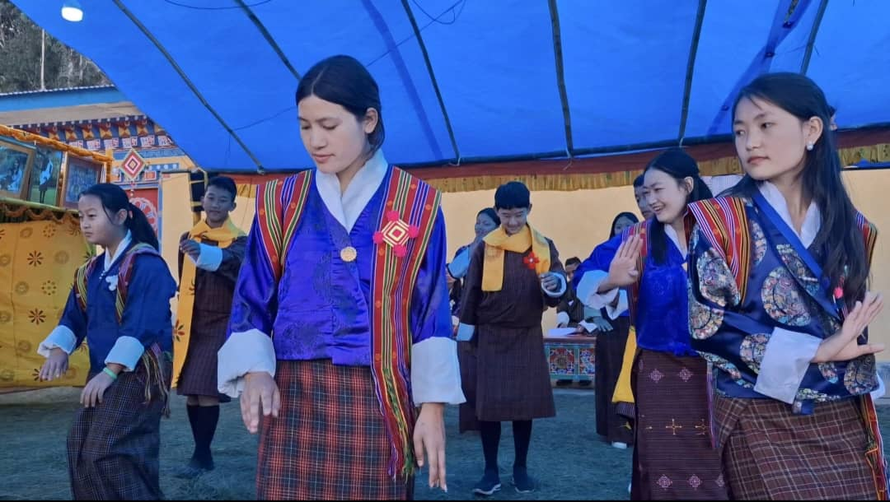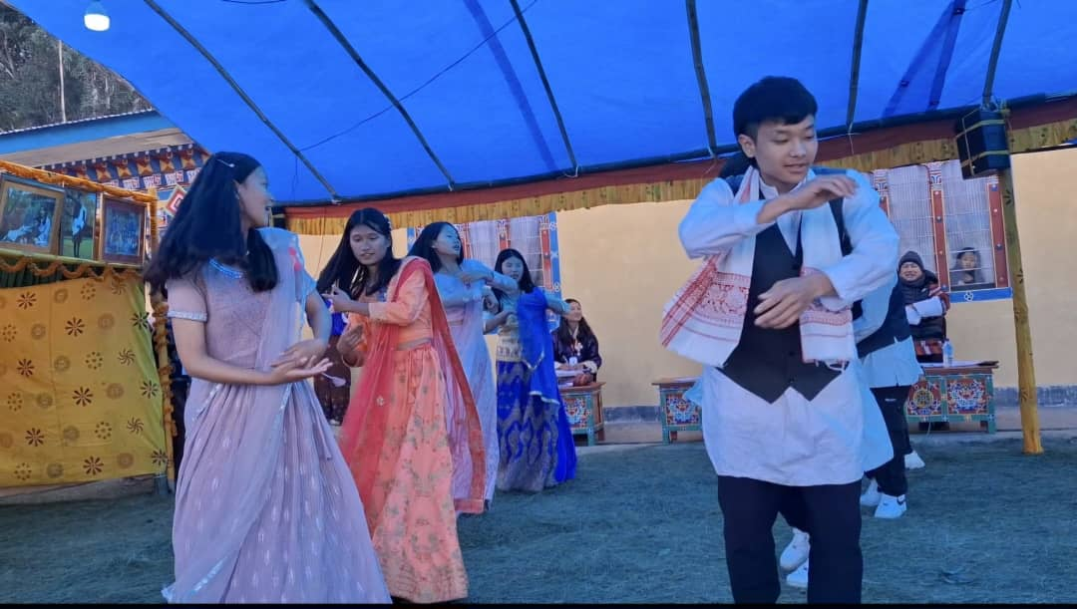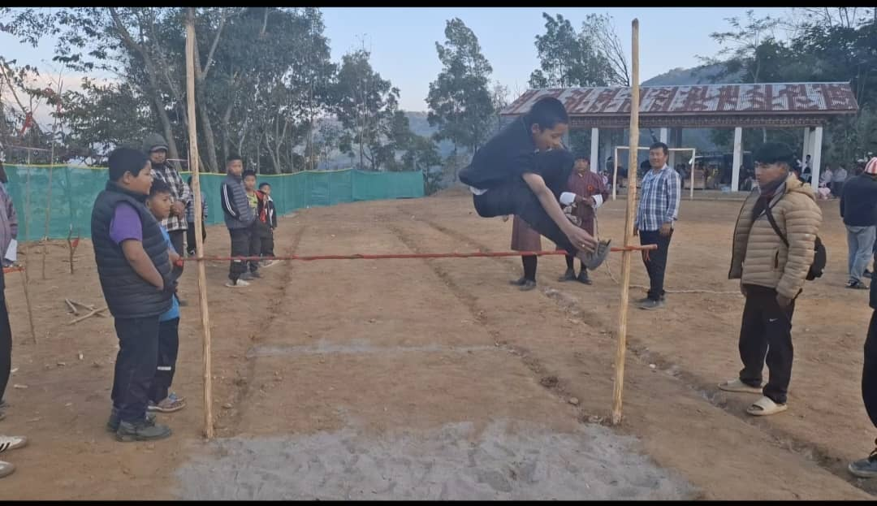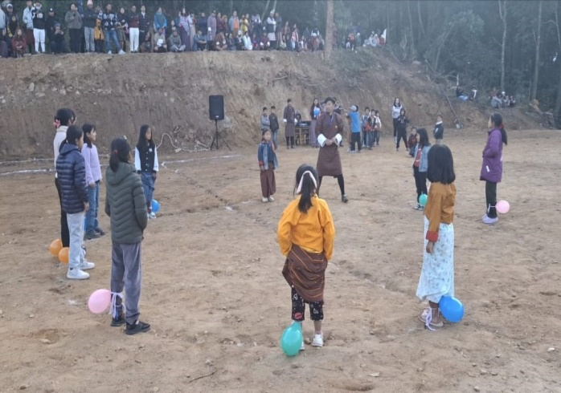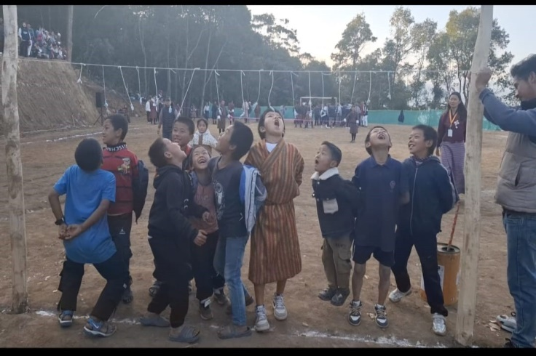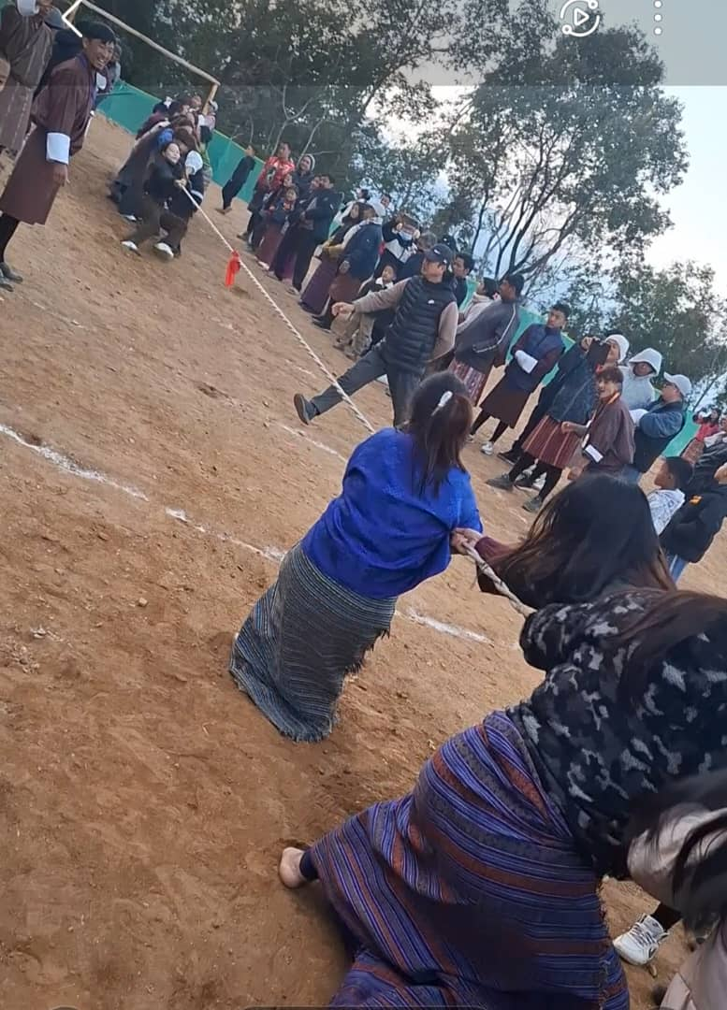

ii. Organic Culture Preservation
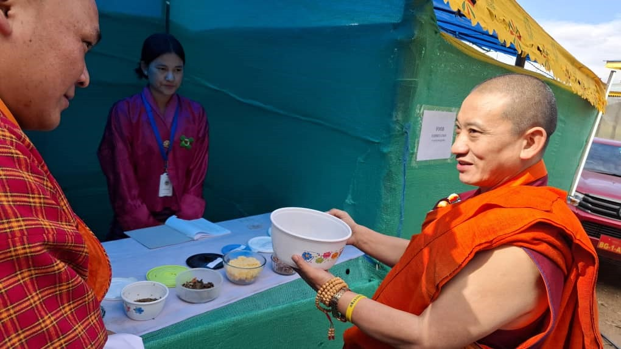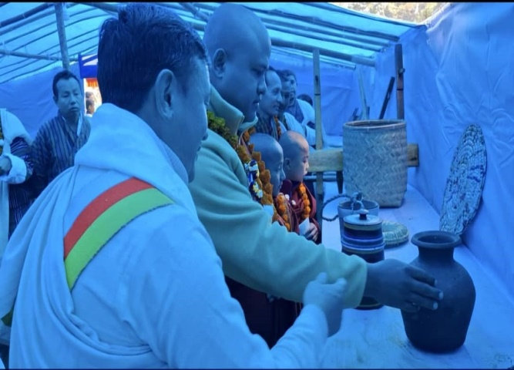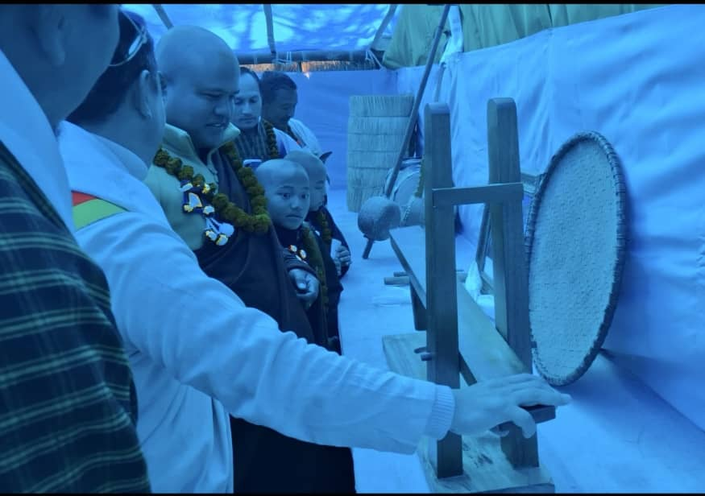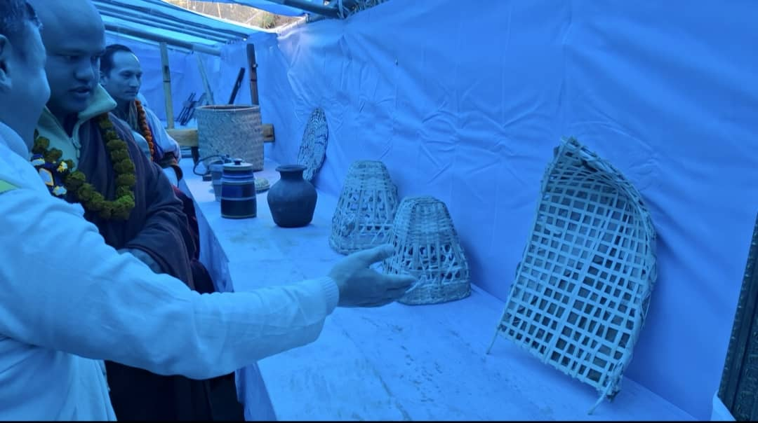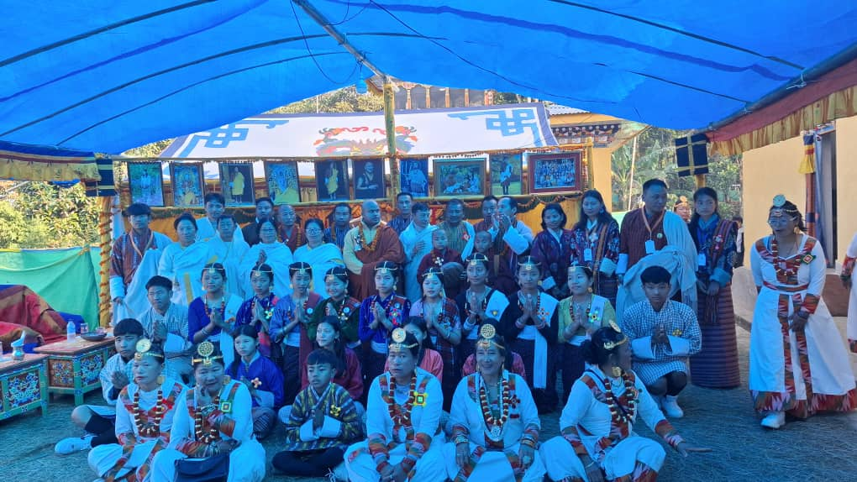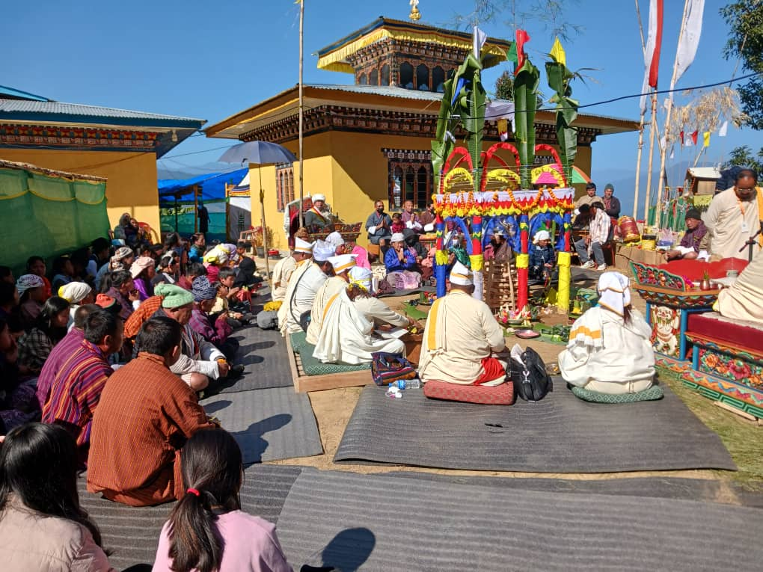

6. To preserve the traditions inherited from our ancestors and the cultural integrity of our nation, Druk Kirat Chhoetshok has consistently organized an awareness program that visits various villages across the Dzongkhags, in conjunction with the Driglam Namza Course on March to April 2025.
i.Practicing driglam namzha preserving culture identity and heritage.
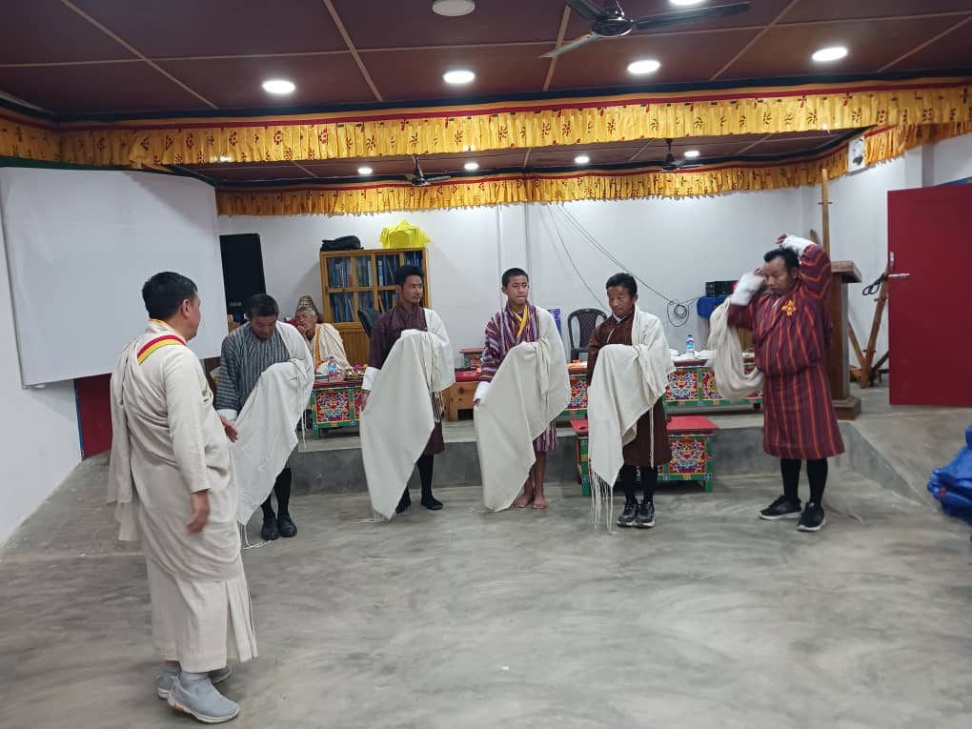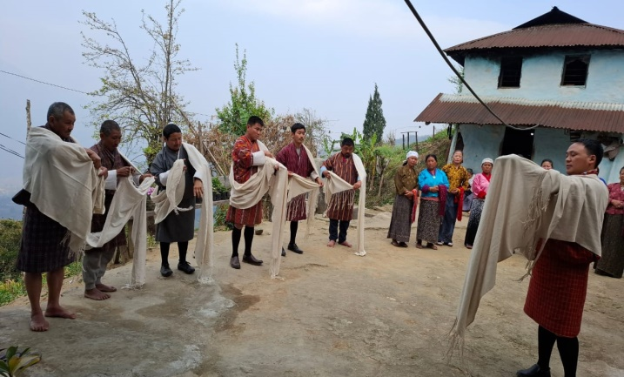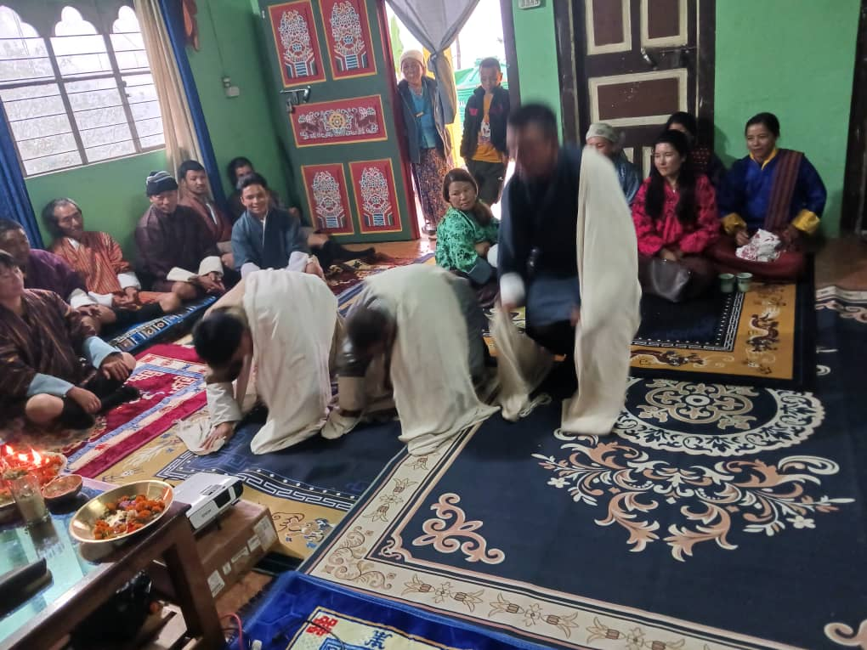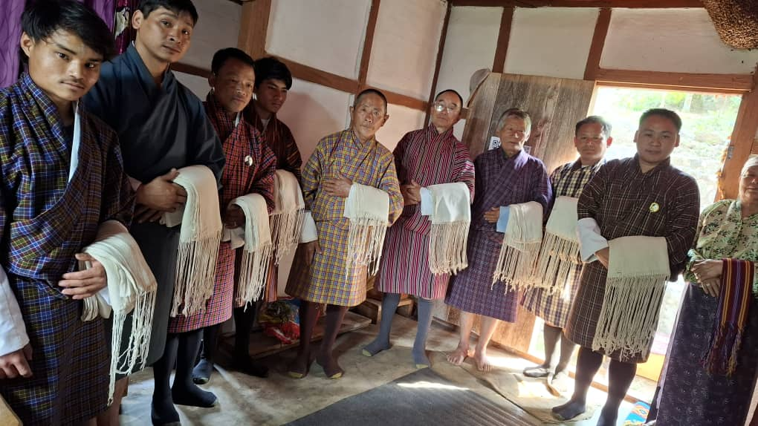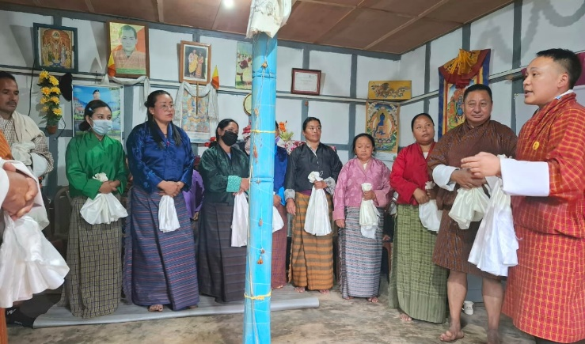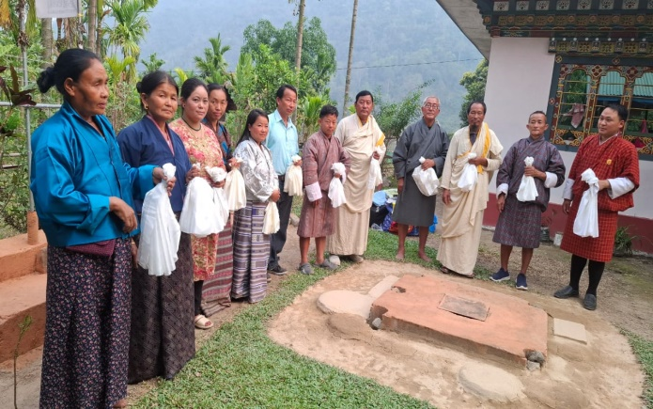

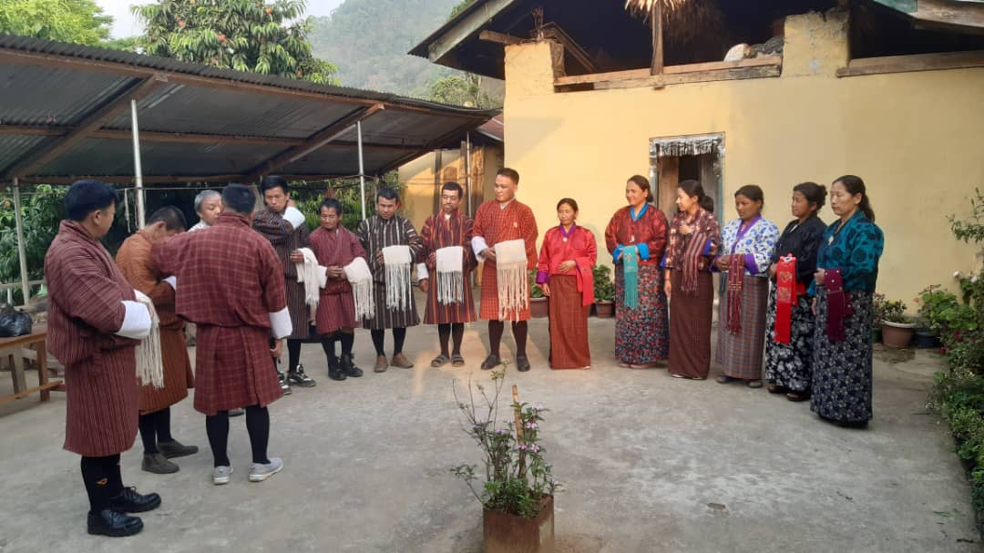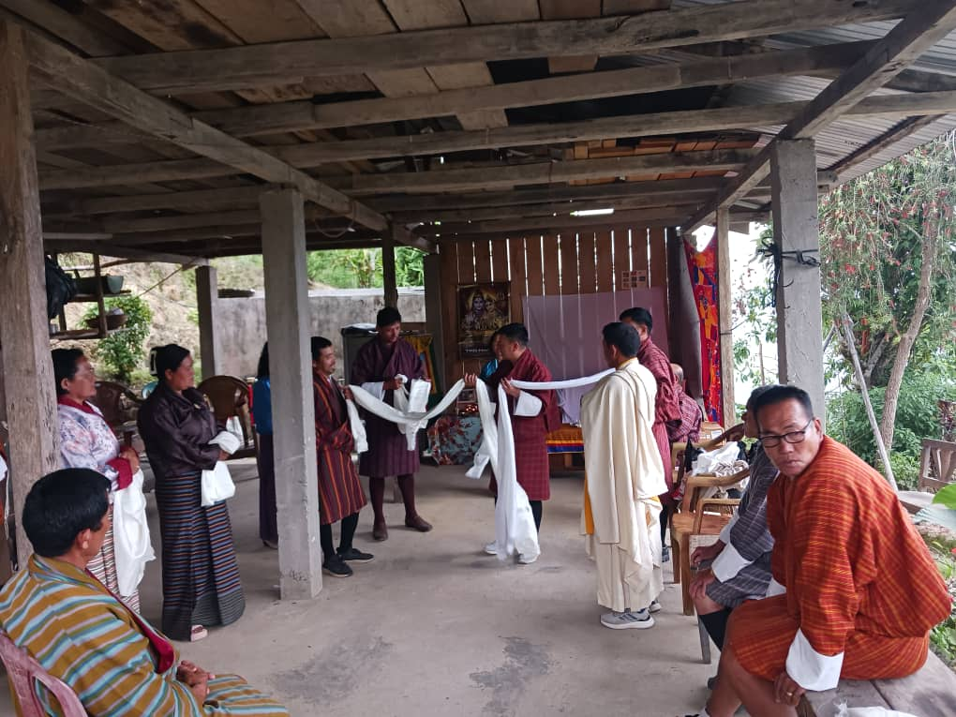
ii. Awareness Program in Southern Dzongkhags
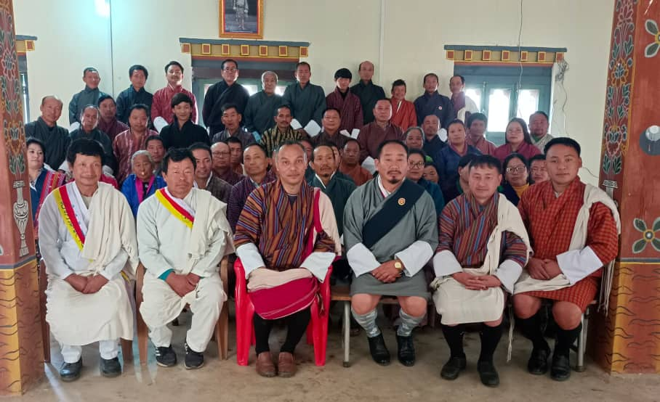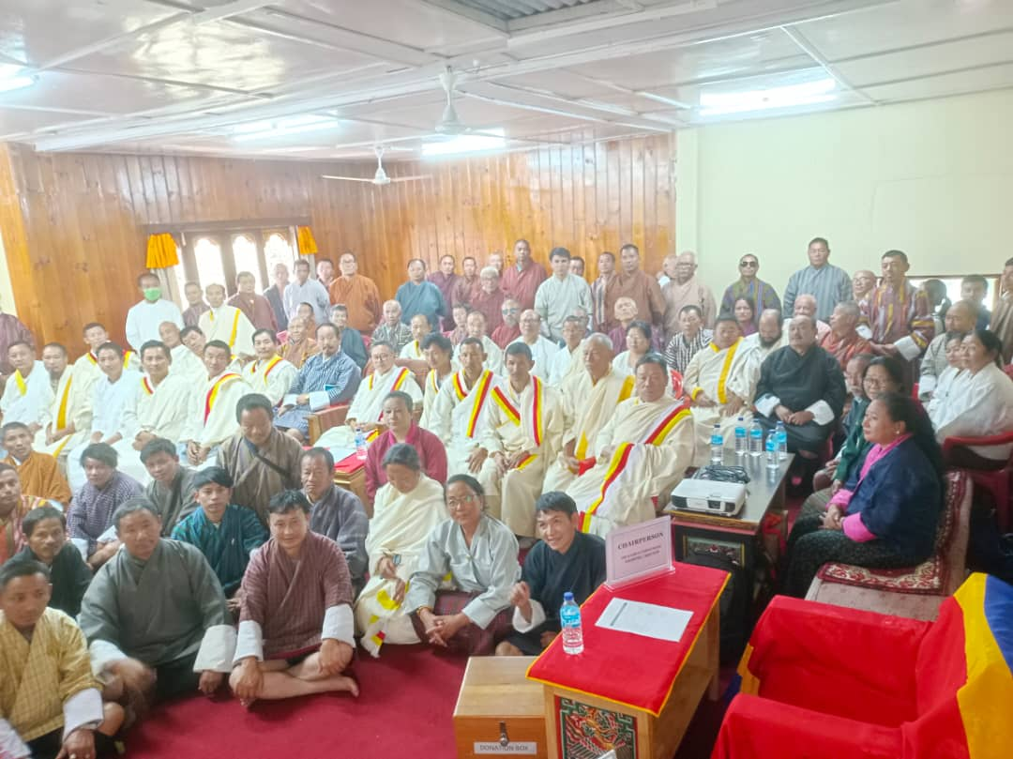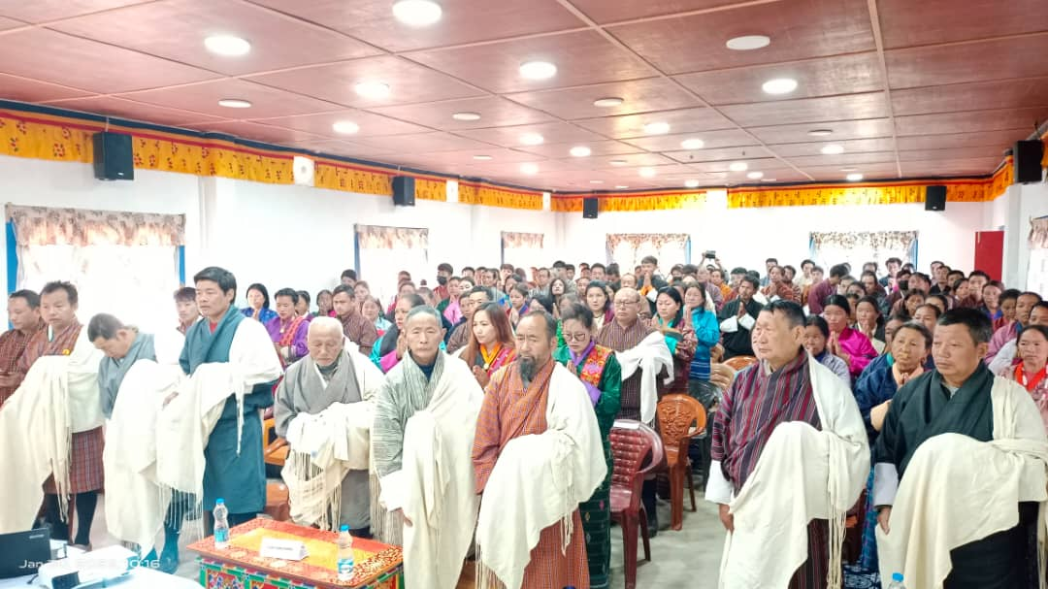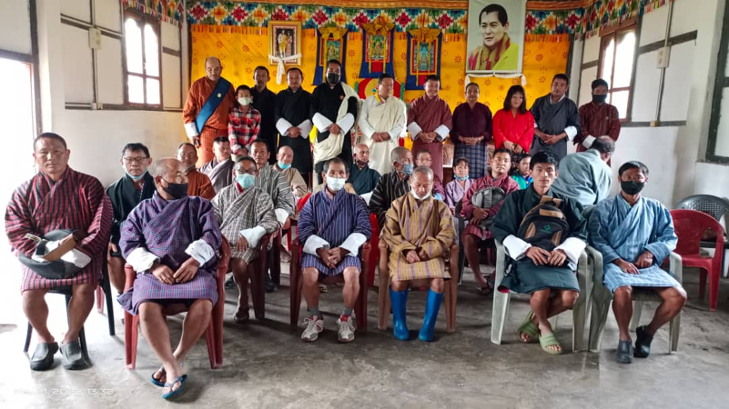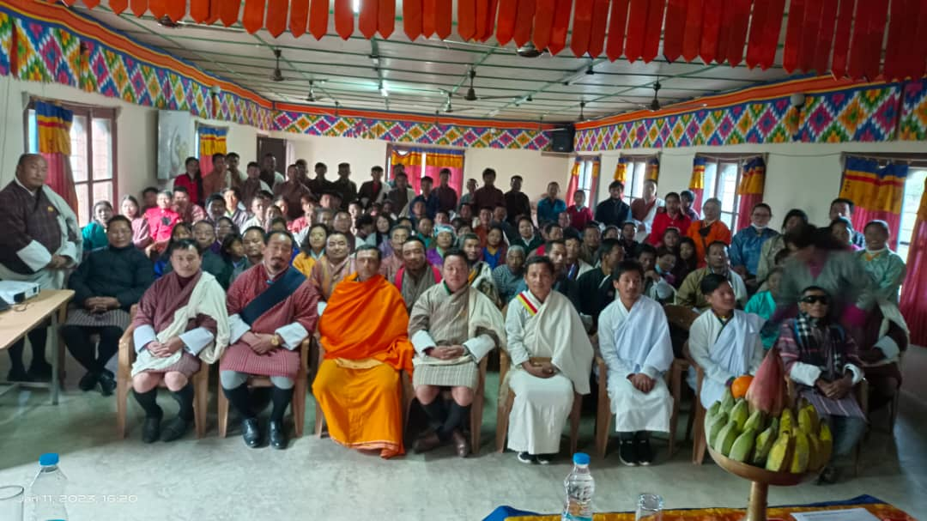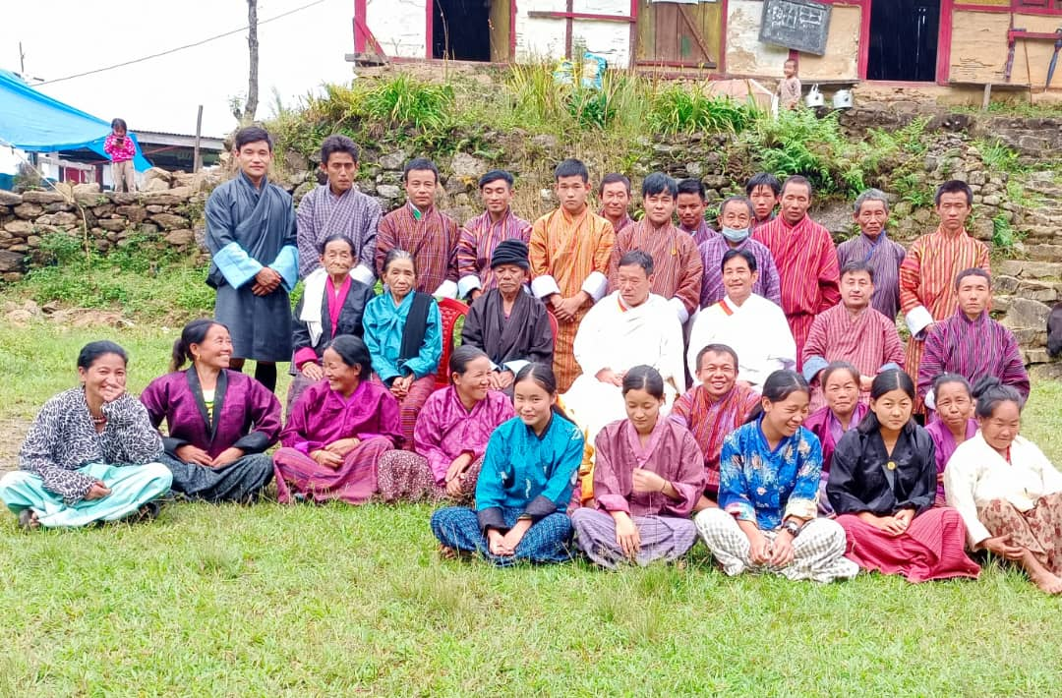
7. The Kirat community found challenges in conducting rituals in accordance with their traditions in the regions of Paro, Haa, Wangdi, Punakha, and Thimphu, where they also experienced loss. To address this matter and serve the interests of the entire community, the Druk Kirat Chhoetshok has acquired a plot of land in Mewang Gewog, Namseling Chiwog, Thimphu, since 2023. This site now provides facilities for the execution of various social services and programs, including naming ceremonies, marriages, ceremony after funeral (Gewa) and more.
i.puja of Dead Ceremony
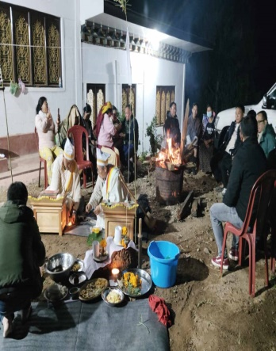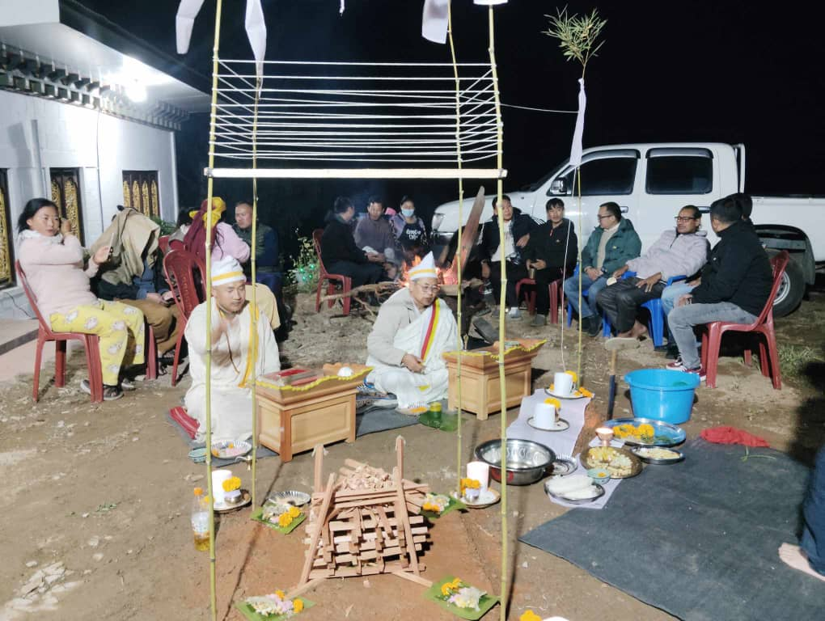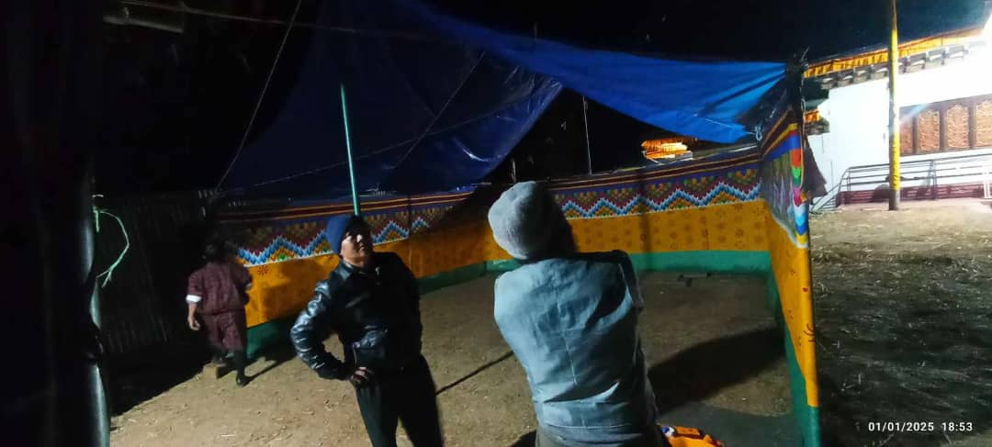
ii. Donation of wheel chair to the disability
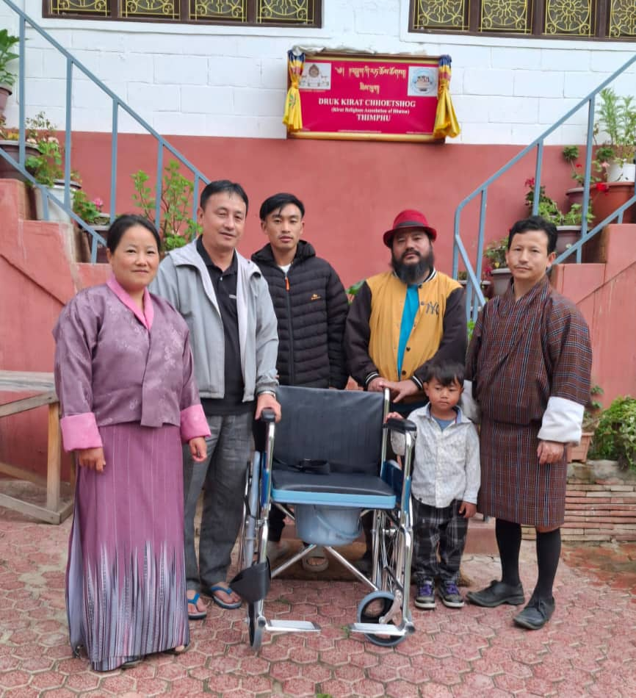

Thank you

